<직접풀어보기 7-3>

<Main>

package com.example.a7_3;  
  
import androidx.appcompat.app.AlertDialog;  
import androidx.appcompat.app.AppCompatActivity;  
  
import android.content.DialogInterface;  
import android.os.Bundle;  
import android.view.Display;  
import android.view.Gravity;  
import android.view.View;  
import android.view.WindowManager;  
import android.widget.Button;  
import android.widget.EditText;  
import android.widget.TextView;  
import android.widget.Toast;  
  
public class MainActivity extends AppCompatActivity {  
 EditText tvName,tvEmail;  
 EditText dlgEdtName,dlgEdtEmail;  
 TextView toastText;  
 View dialogView, toastView;  
 Button btn1;  
 @Override  
 protected void onCreate(Bundle savedInstanceState) {  
 super.onCreate(savedInstanceState);  
 setContentView(R.layout.*activity_main*);  
 setTitle("사용자 정보 입력");  
 tvName=(EditText) findViewById(R.id.*tvName*);  
 tvEmail=(EditText) findViewById(R.id.*tvEmail*);  
 btn1=(Button)findViewById(R.id.*btn1*);  
 btn1.setOnClickListener(new View.OnClickListener() {  
 @Override  
 public void onClick(View view) {  
 dialogView=(View)View.*inflate*(MainActivity.this,R.layout.*dialog1*,null);  
 AlertDialog.Builder dlg=new AlertDialog.Builder(MainActivity.this);  
 dlg.setTitle("사용자 정보 입력");  
 dlg.setIcon(R.mipmap.*ic_launcher*);  
 dlg.setView(dialogView);  
 dlgEdtName=(EditText)dialogView.findViewById(R.id.*edit1*);  
 dlgEdtEmail=(EditText)dialogView.findViewById(R.id.*edit2*);  
  
 //에딧텍스트의 문구를 에딧텍스트에 복사하므로 .toString()함수 필요x  
 dlgEdtName.setText(tvName.getText());  
 dlgEdtEmail.setText(tvEmail.getText());  
 dlg.setPositiveButton("확인", new DialogInterface.OnClickListener() {  
 @Override  
 public void onClick(DialogInterface dialogInterface, int i) {  
 tvName.setText(dlgEdtName.getText());  
 tvEmail.setText(dlgEdtEmail.getText());  
 }  
 });  
  
 dlg.setNegativeButton("취소", new DialogInterface.OnClickListener() {  
 @Override  
 public void onClick(DialogInterface dialogInterface, int i) {  
 Toast toast=new Toast(MainActivity.this);  
 toastView=(View)View.*inflate*(MainActivity.this,R.layout.*toast1*,null);  
 toastText=(TextView)toastView.findViewById(R.id.*textView*);  
 toastText.setText("취소했습니다.");  
 toast.setView(toastView) ;  
 Display display=((WindowManager)getSystemService(*WINDOW_SERVICE*)).getDefaultDisplay();  
 int xoffset=(int)(Math.*random*()*display.getWidth());  
 int yoffset=(int)(Math.*random*()*display.getHeight());  
 toast.setGravity(Gravity.*TOP* | Gravity.*LEFT*,xoffset,yoffset);  
 toast.show();  
 }  
 });  
 dlg.show();  
 }  
 });  
 }  
}

<Activity>

<?xml version="1.0" encoding="utf-8"?>  
<LinearLayout xmlns:android="http://schemas.android.com/apk/res/android"  
 android:layout_width="match_parent"  
 android:layout_height="match_parent"  
 android:orientation="vertical"  
 android:gravity="center_horizontal">  
  
 <EditText  
 android:layout_width="match_parent"  
 android:layout_height="wrap_content"  
 android:id="@+id/tvName"  
 android:hint="사용자 이름"/>  
 <EditText  
 android:layout_width="match_parent"  
 android:layout_height="wrap_content"  
 android:id="@+id/tvEmail"  
 android:hint="이메일"/>  
 <Button  
 android:layout_width="wrap_content"  
 android:layout_height="wrap_content"  
 android:id="@+id/btn1"  
 android:text="여기를 클릭"/>  
  
</LinearLayout>

<dialog>

<?xml version="1.0" encoding="utf-8"?>  
<LinearLayout xmlns:android="http://schemas.android.com/apk/res/android"  
 android:orientation="vertical" android:layout_width="match_parent"  
 android:layout_height="match_parent">  
 <TextView  
 android:layout_width="match_parent"  
 android:layout_height="wrap_content"  
 android:text="사용자 이름"/>  
 <EditText  
 android:layout_width="match_parent"  
 android:layout_height="wrap_content"  
 android:id="@+id/edit1"/>  
 <TextView  
 android:layout_width="match_parent"  
 android:layout_height="wrap_content"  
 android:text="이메일"/>  
 <EditText  
 android:layout_width="match_parent"  
 android:layout_height="wrap_content"  
 android:id="@+id/edit2"/>  
  
</LinearLayout>

<toast>

<?xml version="1.0" encoding="utf-8"?>  
<LinearLayout xmlns:android="http://schemas.android.com/apk/res/android"  
 android:orientation="horizontal" android:layout_width="match_parent"  
 android:layout_height="match_parent"  
 android:background="#ff0000"  
 android:gravity="center">  
 <ImageView  
 android:layout_width="10dp"  
 android:layout_height="10dp"  
 android:src="@drawable/ic_launcher_background"/>  
 <TextView  
 android:layout_width="wrap_content"  
 android:layout_height="wrap_content"  
 android:id="@+id/textView"  
 android:textSize="20sp"  
 android:text="textview"/>  
 <ImageView  
 android:layout_width="10dp"  
 android:layout_height="10dp"  
 android:src="@drawable/ic_launcher_foreground"/>  
  
</LinearLayout>

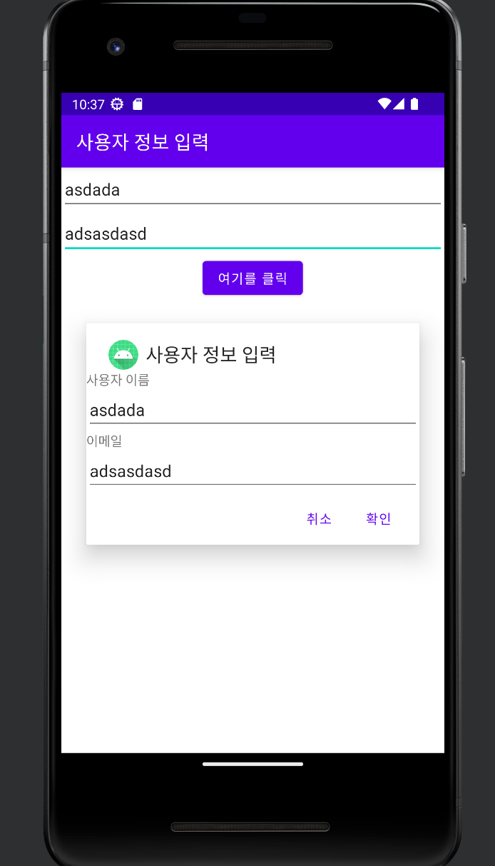

<7-2>

<activity>

<?xml version="1.0" encoding="utf-8"?>  
<LinearLayout xmlns:android="http://schemas.android.com/apk/res/android"  
 xmlns:app="http://schemas.android.com/apk/res-auto"  
 xmlns:tools="http://schemas.android.com/tools"  
 android:layout_width="match_parent"  
 android:layout_height="match_parent"  
 android:orientation="vertical"  
 tools:context=".MainActivity"  
 android:id="@+id/baseLayout">  
  
  
 <Button  
 android:id="@+id/button1"  
 android:layout_width="wrap_content"  
 android:layout_height="wrap_content"  
 android:layout_gravity="center"  
 android:text="배경색 버튼"  
 android:focusable="true"  
 />  
  
 <Button  
 android:id="@+id/button2"  
 android:layout_width="wrap_content"  
 android:layout_height="wrap_content"  
 android:layout_gravity="center"  
 android:text="버튼 변경"  
 android:focusable="true"  
 />  
  
  
</LinearLayout>

<main>

package com.example.a7;  
  
import static android.content.ContentValues.*TAG*;  
  
import androidx.annotation.NonNull;  
import androidx.appcompat.app.AppCompatActivity;  
  
import android.graphics.Color;  
import android.os.Bundle;  
import android.util.Log;  
import android.view.ContextMenu;  
import android.view.Menu;  
import android.view.MenuInflater;  
import android.view.MenuItem;  
import android.view.SubMenu;  
import android.view.View;  
import android.widget.Button;  
import android.widget.LinearLayout;  
  
public class MainActivity extends AppCompatActivity {  
 LinearLayout baseLayout;  
 Button button1, button2;  
  
 @Override  
 protected void onCreate(Bundle savedInstanceState) {  
 super.onCreate(savedInstanceState);  
 setContentView(R.layout.*activity_main*);  
 setTitle("배경색 바꾸기");  
 baseLayout = (LinearLayout) findViewById(R.id.*baseLayout*);  
 button1 = (Button) findViewById(R.id.*button1*);  
 registerForContextMenu(button1);  
 button2 = (Button) findViewById(R.id.*button2*);  
 registerForContextMenu(button2);  
 }  
  
 @Override  
 public void onCreateContextMenu(ContextMenu menu, View v, ContextMenu.ContextMenuInfo menuInfo) {  
 super.onCreateContextMenu(menu, v, menuInfo);  
 if (v == button1) {  
 menu.setHeaderTitle("배경색 변경");  
 menu.add(0, 1, 0, "배경색(빨강)");  
 menu.add(0, 2, 0, "배경색(초록)");  
 menu.add(0, 3, 0, "배경색(파랑)");  
 Log.*e*(*TAG*, "click1");  
 } else if (v == button2) {  
 menu.setHeaderTitle("버튼 동작 변경");  
 menu.add(0, 4, 0, "버튼 45도 회전");  
 menu.add(0, 5, 0, "버튼 2배 확대");  
 Log.*e*(*TAG*, "click2");  
 }  
 }  
  
  
 @Override  
 public boolean onContextItemSelected(MenuItem item) {  
 switch(item.getItemId())  
 {  
 case 1:  
 baseLayout.setBackgroundColor(Color.*RED*);  
 break;  
 case 2:  
 baseLayout.setBackgroundColor(Color.*GREEN*);  
 break;  
 case 3:  
 baseLayout.setBackgroundColor(Color.*BLUE*);  
 break;  
 case 4:  
 button2.setRotation(45);  
 break;  
 case 5:  
 button2.setScaleX(2);  
 break;  
 }  
 return true;  
 }  
}

